**LoTW Synchronization From Club Log**

# Aki Yoshida JA1NLX

## 1.0 GENERAL

Logger32 provides a feature which synchronizes LoTW Credit Granted status with the status on the Club Log database. You should be a user of Club Log and LoTW to use this feature.

Note:

Logger32 does not flag the thousands of duplicate country/band/mode credits for QSOs from Club Log, only one. There is no prize for having 1000 QSOs granted by LoTW for US QSOs on 20M CW, only one is needed/counted. If you REALLY must have thousands of QSOs granted by LoTW, then use one of the other update methods in Logger32 like “Synchronize LoTW (from an ADIF file) etc

## 2.0 PREPARATION

1) Upload your all QSOs to LoTW.

2) Go to <https://secure.clublog.org/lotw/> and select “**Download confirmed QSOs from LoTW**”. Details are not explained here. Please read the guide provided by Club Log in the link above.

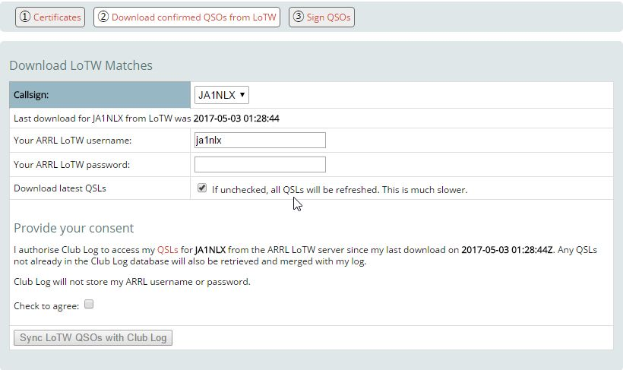

LOTWCL_1

## 3.0 SYNCHRONIZE LOTW FROM CLUB LOG

Click File and Synchronize LoTW (from Club Log.)

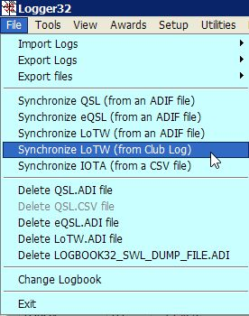

LOTWCL_2

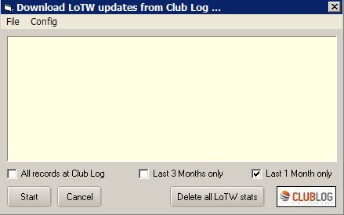

LOTWCL_3

Select the Config menu option and enter the Callsign, Password and eMail address for Club Log and Click Apply.

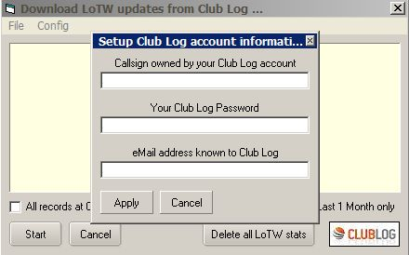

LOTWCL_4

Club Log has only very recently (May 2017) introduced the capability of reporting QSOs that have been credited for DXCC by LoTW. While Club Log may know of QSOs that are eligible for LoTW credit, it can not definitively say what of these QSOs loaded to Club Log prior to May 2017 have credit granted. To update all your QSOs on Club Log, you need to UNcheck the option shown in LOTWCL_1. This will refresh all your LoTW credits in the Club Log databases. It's slower than normal, but it will ensure you get the most current LoTW credits. You need only do this once.

If you want to synchronize Logbook by confirmed QSOs for last 1 month then check Last 1 month only.

If you want to synchronize Logbook by confirmed QSOs for last 3 months then check Last 3 months only.

If you want to synchronize Logbook by all confirmed QSOs at Club Log then check All records at Club Log. You should check this option when you run LoTW Synchronization from Club Log for the first time.

Click Start to synchronize.

When it completes the process the result is displayed. There may be “QSO not found”

This is caused mostly by unmatched mode between in your Logbook and data in ClubLog/LoTW.

For example:

PSK31 in your Logbook and PSK in Club Log/LoTW

FT8 in your Logbook and DATA in Club Log/LoTW etc

In this case,

PSK31 slot should be configured in Band/Mode setup table. PSK31 should be configured as Digital mode in Setup phone/digital mode table.

FT8 slot should be configured in Band/Mode setup table. FT8 should be configured as Digital mode in Setup phone/digital mode table.

Logger32 automatically convert mode data from Club Log if these are configured properly.

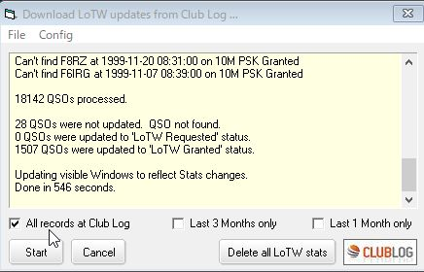

LOTWCL_5

This is the result message when it completes the process successfully with no error.

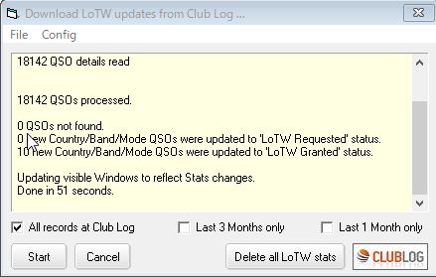

LOTWCL_6

## 4.0 NOTES

It may take a long time to complete update when Logger32 need to update for many QSOs. (just after deleting all LoTW Credit Granted status) However once it updated then it is faster next time.

Downloaded QSOs records are saved as “LoTW records from ClubLog.txt” (JSON format) in the Logger32 folder. Sample below.

["VE7AHA","2013-12-31 23:41:41","12","CW","C"],["W9WI","2013-12-29 22:38:06","15","CW","C"],["3W1T","2013-12-27 00:36:35","10","CW","C"],["YB4IR\/8","2013-12-25 22:19:21","20","CW","C"],["YF1AR\/8","2013-12-23 11:39:13","20","SSB","C"],["YB4IR\/8","2013-12-23 03:18:01","15","CW","C"],["YF1AR\/8","2013-12-22 05:51:26","15","SSB","C"],["YB4IR\/8","2013-12-21 23:25:48","17","CW","C"],["ZM90DX","2013-12-18 02:42:55","12","CW","G"],["RW110RAEM","2013-12-10 07:49:41","12","CW","C"],["V63XG","2013-12-10 07:34:17","15","CW","C"],["T32RC","2013-12-09 08:53:15","30","CW","C"],["V63XG","2013-12-09 07:18:09","20","CW","C"],["J69DS","2013-11-29 22:57:36","15","RTTY","C"],["C6AUM","2013-11-29 12:28:09","40","CW","C"],